**Indian General Election 2024 Analysis**

**Prasanjit Rout|** [**https://www.linkedin.com/in/routprasanjit933/**](https://www.linkedin.com/in/routprasanjit933/)

1. **Total Seats Available**
2. **Query** 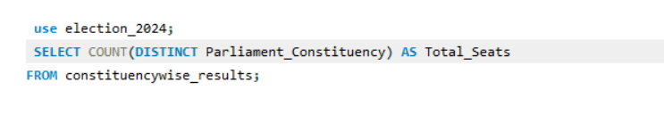
3. **Result**

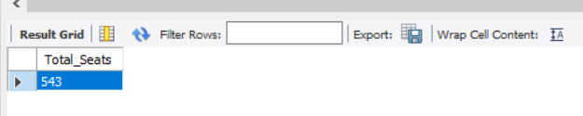

1. **Total Seats Won by NDA Alliance**
2. **Query**

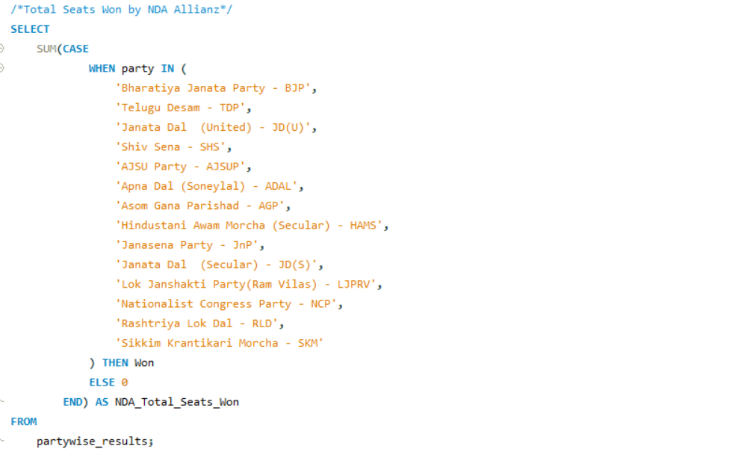

1. **Result**

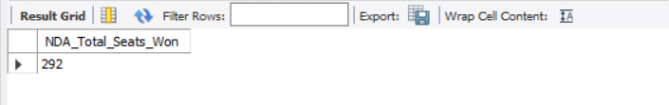

1. **Seats Won by NDA Alliance Parties**
2. **Query**

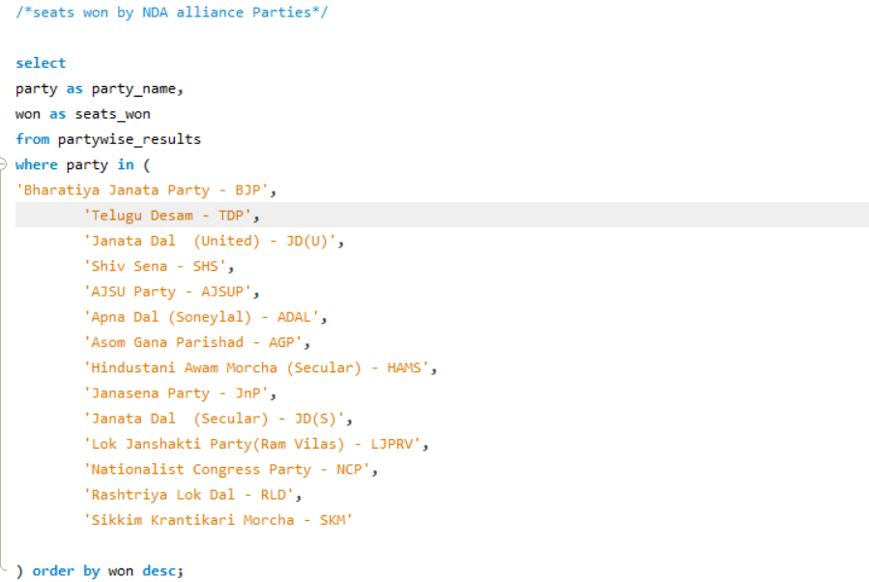

1. **Result**

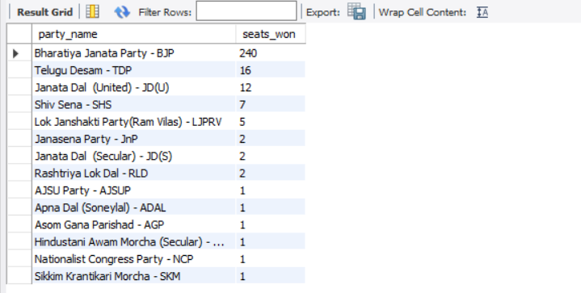

1. **Total Seats Won By I.N.D.I.A Alliance**
2. **Query**

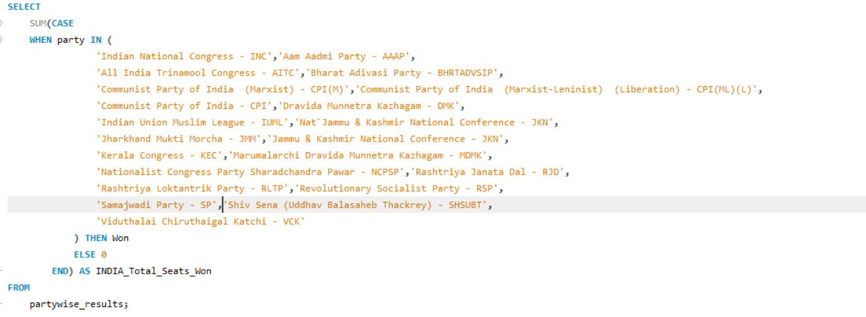

1. **Results**

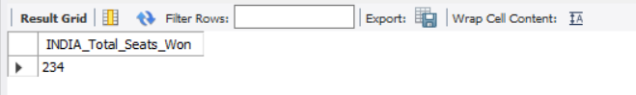

1. **Seats Won by I.N.D.I.A Alliance parties**
2. **Query**

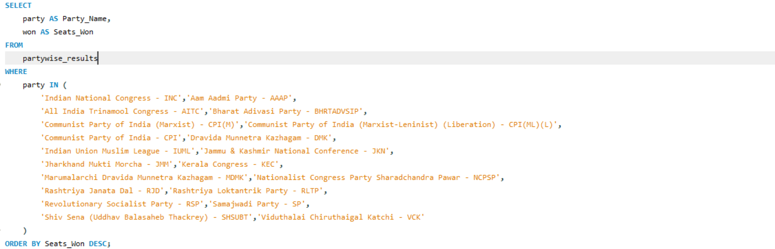

1. **Results**

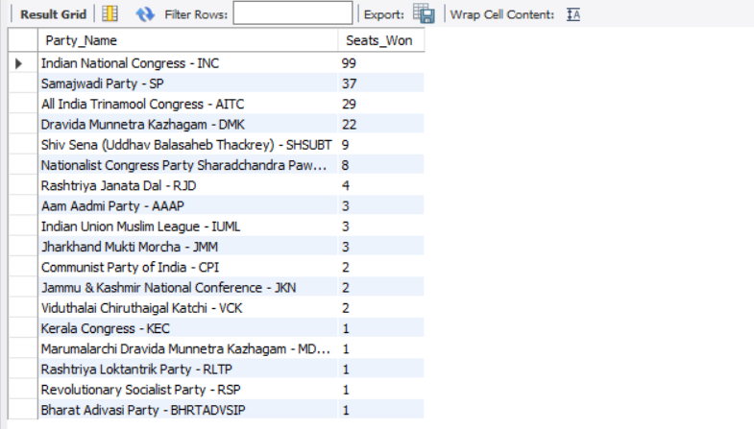

**Learning & Outcomes:**

1. **Use of Basic SQL Functions like Count, Group By, Where, Distinct, SUM.**
2. **Use of Case to do the grouping**
3. **Create, Read & Delete**

**This Project Analysis helps me to execute basic queries and to gain experiences for handling big large queries.**